February 14 2024

Ash Wednesday

Call to Worship: 3 bells

Gathering: “Within Our Darkest Night”
by Jacques Berthier © 1991, GIA Publications, Inc.

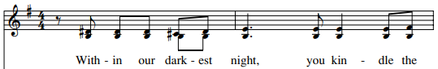

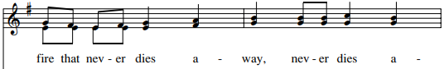

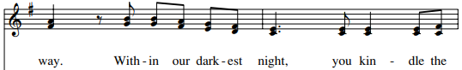

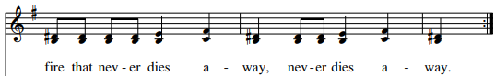

Liturgy of the Word

A reading from the Book of Joel (2:12-18)
Even now, says the LORD, return to me with your whole heart, with fasting, and weeping, and mourning; rend your hearts, not your garments, and return to the LORD, your God.

Page | 1
Responsorial: Psalm 51 – “Create A Clean Heart”
by Cyprian Consiglio © 2000, OCP

REFRAIN: Cantor, then All
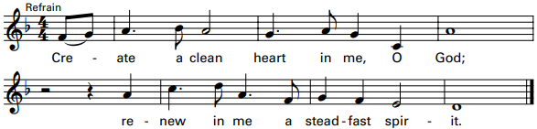

A reading from the Second Letter of Saint Paul to the Corinthians (5:20-6:2)
Brothers and sisters: We are ambassadors for Christ, as if God were appealing through us. We implore you on behalf of Christ, be reconciled to God. For our sake he made him to be sin who did not know sin, so that we might become the righteousness of God in him.

Gospel Acclamation: “Praise to You”
by Joe Mattingly © 2000, World Library Publications, Inc.

REFRAIN: (1st time) Cantor, then All

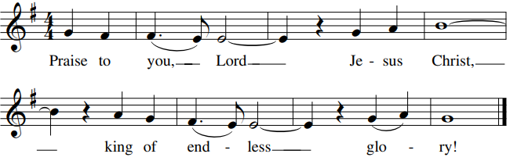

Verse: If today you hear his voice, harden not your hearts.

A reading from the Gospel according to Matthew (6:1-6, 16-18)
Jesus said to his disciples: “Take care not to perform righteous deeds in order that people may see them; otherwise, you will have no recompense from your heavenly Father. When you give alms, do not blow a trumpet before you, as the hypocrites do in the synagogues and in the streets to win the praise of others. Amen, I say to you, they have received their reward. But when you give alms, do not let your left hand know what your right is doing, so that your almsgiving may be secret. And your Father who sees in secret will repay you.”

HOMILY

Page | 2
Invitation into Lenten Renewal…
Music for the Imposition of Ashes

“Take, O Take Me as I Am”
by the Iona Community © 1995, Iona Community, GIA.

REFRAIN:
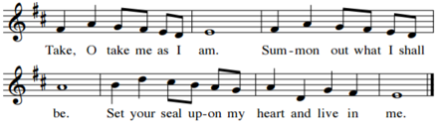
Page | 2

“Leave the Past in Ashes”
by Cyprian Consiglio © 2004, Oregon Catholic Press

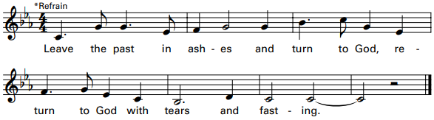

INTERCESSIONS

Liturgy of the Eucharist

Preparation of the Gifts: “Healer of My Soul” – Cantor/Choir
by John Michael Talbot

Healer of my soul, keep me at even’,
keep me at morning, keep me at noon,
Healer of my soul.

Keeper of my soul, on rough course faring,
help and safeguard my means this night.
Keeper of my soul.

I am tired, astray and stumbling.
Shield my soul from the snare of sin.

Page | 3

Eucharistic Acclamations from Missa Pacem
by L. Randolph Babin © 2004, 2010, GIA Publications, Inc.

.
HOLY
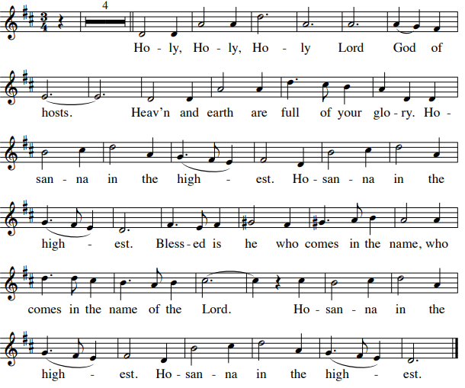

MEMORIAL ACCLAMATION
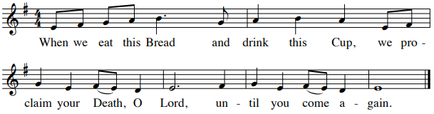

AMEN
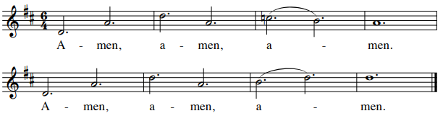

LORD’S PRAYER

SIGN OF PEACE

Page | 4
Lamb of God from Missa Pacem

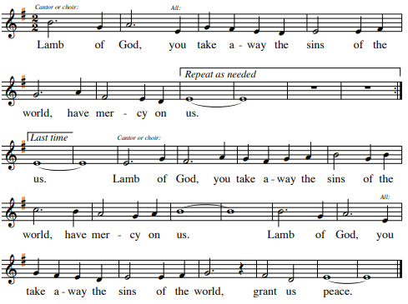
(Repeat one time)

Communion Procession: “Now in This Banquet”
by Marty Haugen © 1986, GIA Publications, Inc.

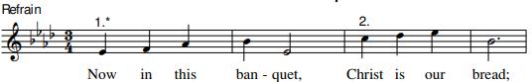

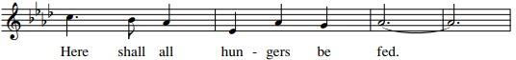

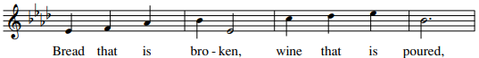

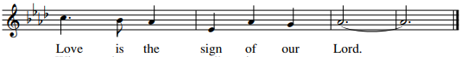

Recessional: Instrumental

Page |5

Stations, Soup & Sustenance
Fridays during Lent

February 16 – 5:30 PM - Blessed Sacrament

February 23 – 5:30 PM – Roncalli Newman
Speaker: Lucas Herro
“Turning Tragedy into Triumph”

March 1 – 5:30 PM – Blessed Sacrament

March 8 – 5:30 PM – Roncalli Newman
Speaker: Rick Kyte
“Friendship”

March 15 – 5:30 PM – Blessed Sacrament

March 22 – 5:30 PM – Roncalli Newman
Speaker: TBD

Page |6 Music printed per One License Account #703788-A

