15/16 October 2022
29th Sunday in Ordinary Time
Gathering Hymn: “Not Alone Where Silent Woodlands”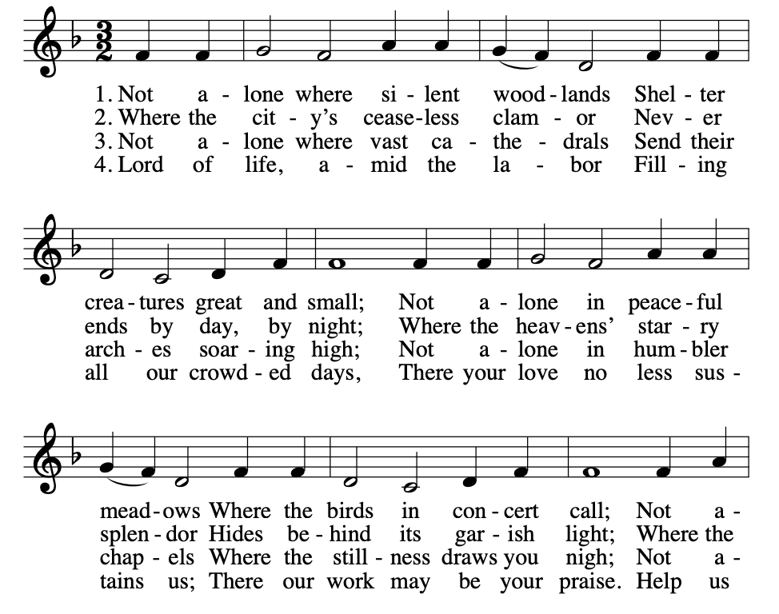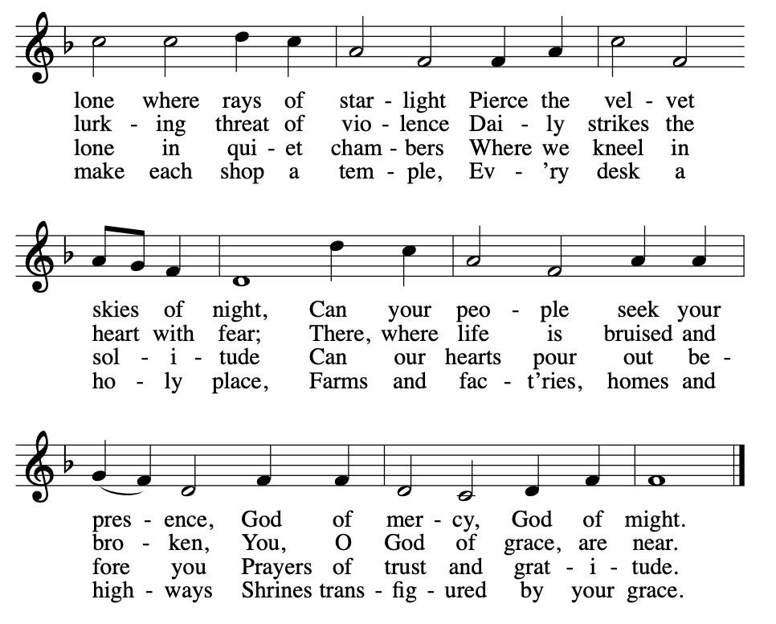
“Penitential Act” from Mass of St. Frances Cabrini (spoken)
“Glory to God” from Mass of St. Frances Cabrini
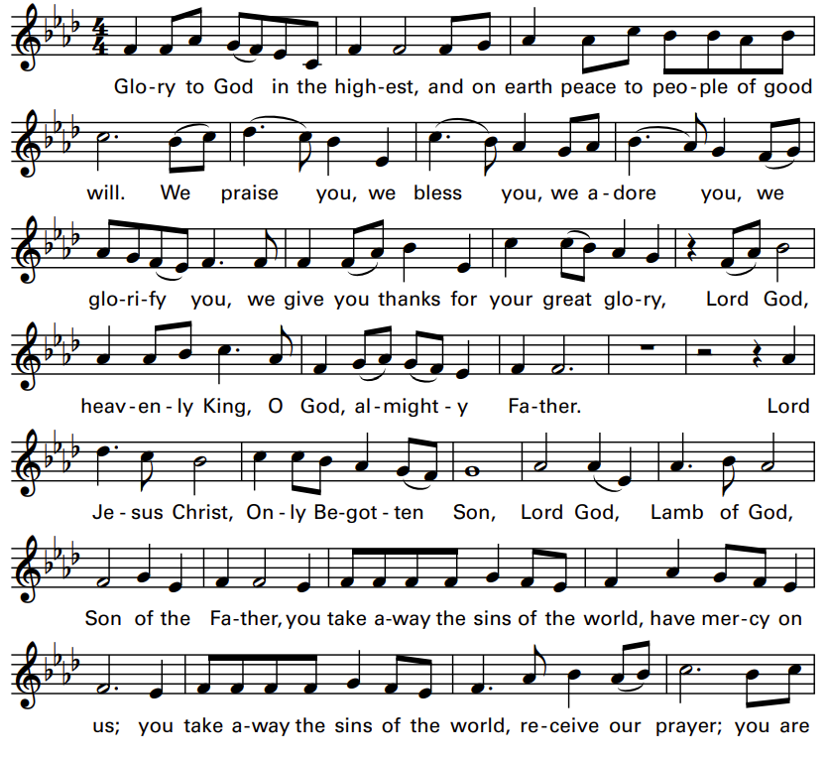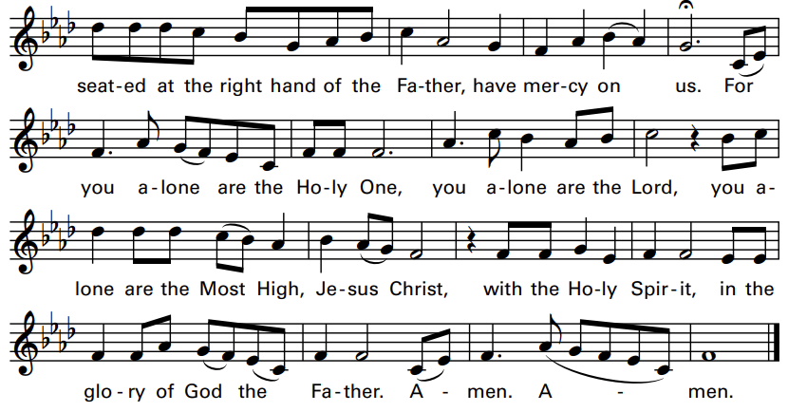

Liturgy of the Word
A reading from the Book of Exodus (17:8-13)
So Joshua did as Moses told him: he engaged Amalek in battle after Moses had climbed to the top of the hill with Aaron and Hur. As long as Moses kept his hands raised up, Israel had the better of the fight, but when he let his hands rest, Amalek had the better of the fight. Moses' hands, however, grew tired; so they put a rock in place for him to sit on.
Responsorial Psalm:
“Psalm 121 – Our Help Is from the Lord”
by Michel Guimont © GIA Publications, Inc.
REFRAIN (Cantor, then ALL):
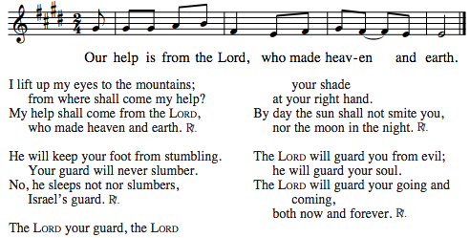

A reading from the second letter to Timothy (13:14 – 4:2)
I charge you in the presence of God and of Christ Jesus, who will judge the living and the dead, and by his appearing and his kingly power: proclaim the word; be persistent whether it is convenient or inconvenient; convince, reprimand, encourage through all patience and teaching.

Gospel Acclamation: from Mass of St. Frances Cabrini
Refrain (Cantor, then ALL):
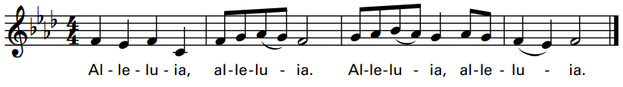
Verse: The word of God is living and effective,
discerning reflections and thoughts of the heart.

A reading from the Gospel according to Luke (18:1-8)
The Lord said, "Pay attention to what the dishonest judge says.
Will not God then secure the rights of his chosen ones who call out to him day and night? Will he be slow to answer them? I tell you, he will see to it that justice is done for them speedily. But when the Son of Man comes, will he find faith on earth?"

HOMILY
NICENE CREED
I believe in one God, the Father almighty,
Maker of heaven and earth,
of all things visible and invisible.
I believe in one Lord Jesus Christ, the Only Begotten
Son of God, born of the Father before all ages.
God from God, Light from Light, true God from true God,
begotten, not made, consubstantial with the Father;
through him all things were made.
For us (men) and for our salvation
he came down from heaven,
[bow] and by the Holy Spirit was incarnate of the Virgin Mary,
and became man.
For our sake he was crucified under Pontius Pilate,
he suffered death and was buried,
and rose again on the third day
in accordance with the Scriptures.
He ascended into heaven
and is seated at the right hand of the Father.
He will come again in glory to judge the living and the dead
and his kingdom will have no end.
I believe in the Holy Spirit, the Lord, the giver of life,
who proceeds from the Father and the Son,
who with the Father and the Son is adored and glorified,
who has spoken through the prophets.
I believe in one holy, catholic and apostolic Church.
I confess one baptism for the forgiveness of sins and
I look forward to the resurrection of the dead
and the life of the world to come. Amen.

GENERAL INTERCESSIONS
LITURGY of the EUCHARIST
Preparation of the Gifts:

Eucharistic Acclamations: from Mass of St. Frances Cabrini
HOLY:
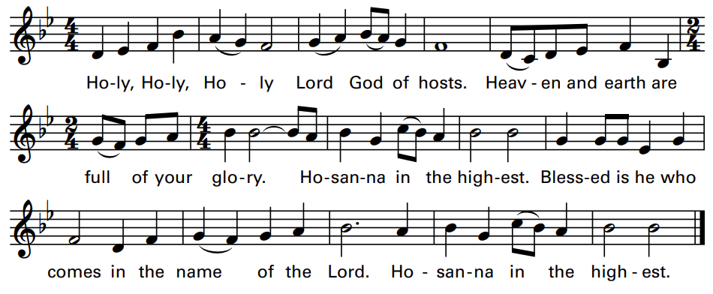
MEMORIAL ACCLAMATION:
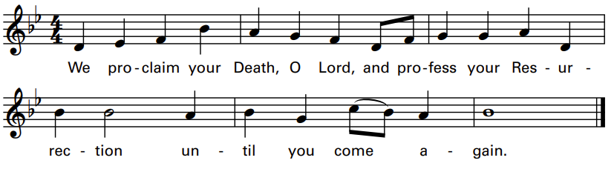
AMEN:
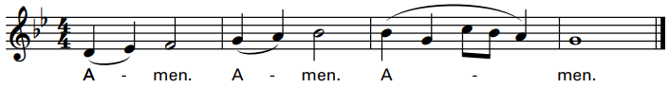
The Lord’s Prayer
Sign of Peace

LAMB of GOD:
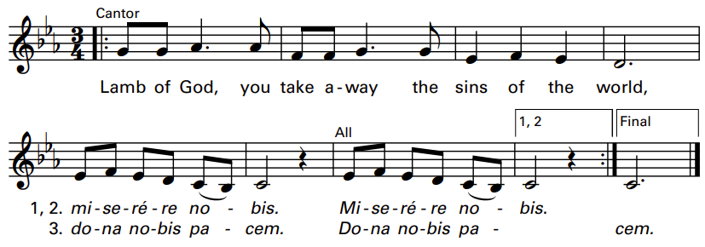

Music for the Communion Procession:
“Be Still and Know That I Am God” by Steve Warner

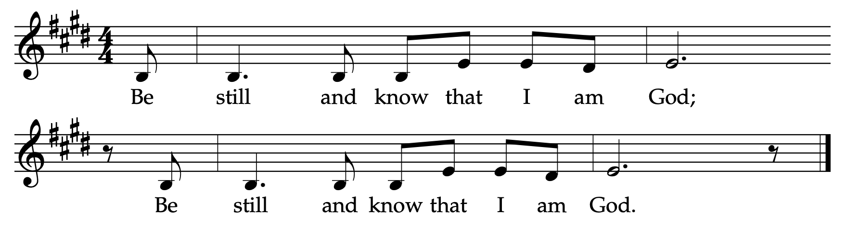

Music for the Communion Procession:

“Now Thank We All Our God”
