The Parables of Grace

I. Reading the Words of Jesus

II. God’s Presence as the Seed – Matthew 13.1-9

A. God’s Presence May Not Look like Much

B. Seeds Disappear for a Time

C. God Uses the Bad Experiences

D. God Playfully Throws the Seeds Everywhere

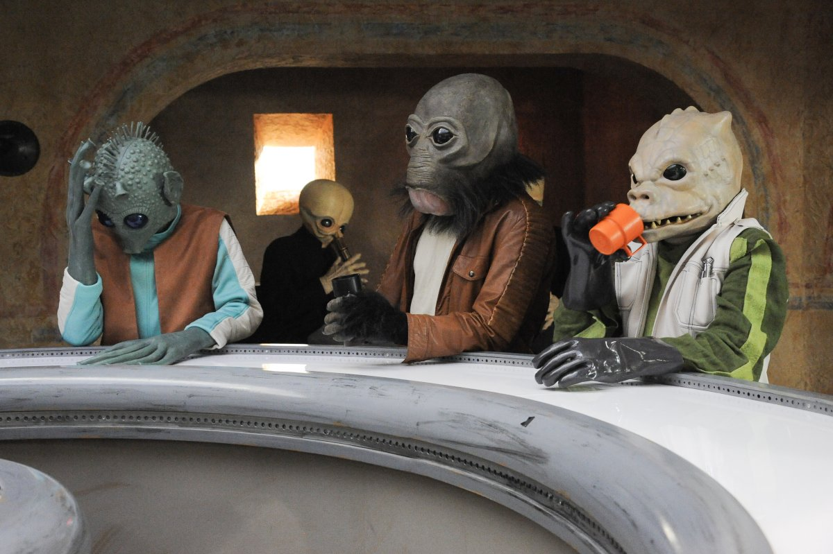
E. The Leaven – Matthew 13.33

III. The Weeds - Matthew 13.24-30

A. The Weeds Look like Wheat

B. Was Matthew Struggling? – Mark 4.26-29

C. Let it Be. Let it Be

D. Let God Do it at the End

IV. The Net – Matthew 13.47-50

A. The Net Catches Everything

B. The Good (kala), the Bad (sapra) and the Ugly (Chicago Bears)

C. Abe the Junk Collector

D. Lisa and the Tree House

E. Grace Always Bats Last

V. “You Say” by Lauren Daigle

I keep fighting voices in my mind that say I’m not enough
Every single lie that tells me I will never measure up
Am I more than just the sum of every high and every low?
Remind me once again just who I am, because I need to know.

You say I am loved when I can’t feel a thing
You say I am strong when I think I am weak
You say I am held when I am falling short
When I don’t belong, oh You say that I am Yours
And I believe, oh I believe.
What You say of me.
I believe

The only thing that matters now is everything You think of me
In You I find my worth, in You I find my identity.

You say I am loved when I can’t feel a thing
You say I am strong when I think I am weak
And You say I am held when I am falling short
When I don’t belong, oh You say that I am Yours
And I believe, oh I believe
What You say of me
Oh, I believe

Taking all I have and now I'm laying it at Your feet
You have every failure God, and You'll have every victory.

You say I am loved when I can’t feel a thing
You say I am strong when I think I am weak
You say I am held when I am falling short
When I don’t belong, oh You say that I am Yours
And I believe, oh I believe
What You say of me
I believe.

Oh I believe, yes I believe
What You say of me
Oh I believe.

